1. Usually, Document is in JSON format before being stored in MongoDB. When it’s stored in MongoDB, it’s converted into BSON before getting stored.
2. 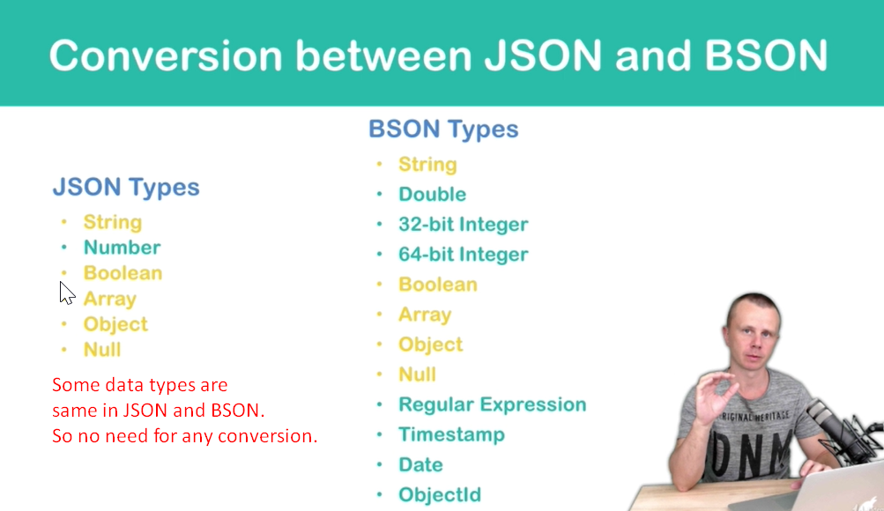
3. 